Change of Ownership SOP

Version 0.1
Date: 13 Nov 2025

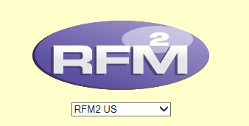

Document Revision History

Version No. | Version Description | Author/ Date | Reviewers/ Date | Approving Party/ Date
0.1 | Updates:  1. Early Access Process Update w.r.t to ABC enablement  2. COO Validation Checklist form created | Saumya Agarwal  11-13-2025 | Muskan T  11-13-2025 | Gautam
1.0

Contents
Change of Ownership SOP 1
Revision History and Version Table 2
Purpose 4
Scope of the Document: Change of Ownership Deployment Process 4
Introduction 4
Field Surveys Overview: 4
Change of Ownership Overview: 4
Types of Change of Ownership 6
Traditional Change of Ownership: 6
Silent Change of Ownership: 7
End – to – End Workflow: 7
Early access 11
When do we provide early access? 11
When do we perform the COO? 14
Traditional COO Process: 14
Silent COO Process: 28
Additional work for MoCopo Store: 36
Validation POST Deployment: 36
Final Email Formats: 37
Traditional COO: 37
Silent COO: 37

Purpose
To guide team members through the end-to-end process of receiving, approval, updating, performing, and tracking Change of Ownership Access request in RFM
Scope of the Document: Change of Ownership Deployment Process
Following steps:
- Receiving and interpreting COO Survey
- Pre-work – Analysis Executing changes
- OTM Approval
- Calendar invite & Tracker update
- Early access/Perform
- Final Email Communication

Introduction
Field Surveys Overview:
Field Surveys refer to requests initiated directly from the field — typically by users, store admin and from OTIMs/STIMs. These surveys generally cover the following three areas:
- Change of Ownership
- Store Build
- Kiosk Breakfast Hours

Change of Ownership Overview:
Change of Ownership is a process of changing ownership from one person to another.
- When the field team requires support for a Change of Ownership, they submit a Change of Ownership Survey Form.
- The requestor fill this survey form Change of Ownership whoso ever have the access


Fill the required (*) details in the survey.

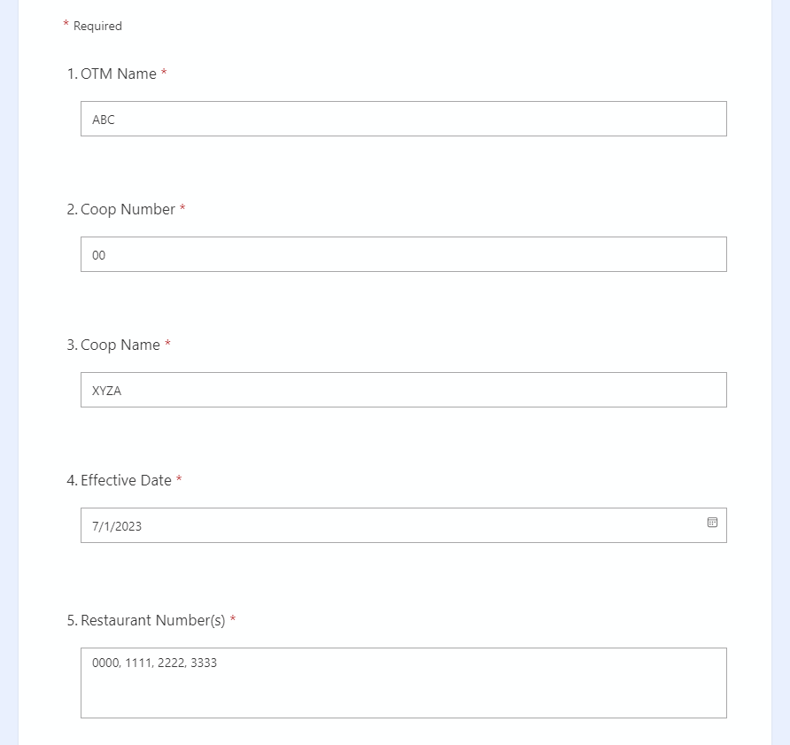
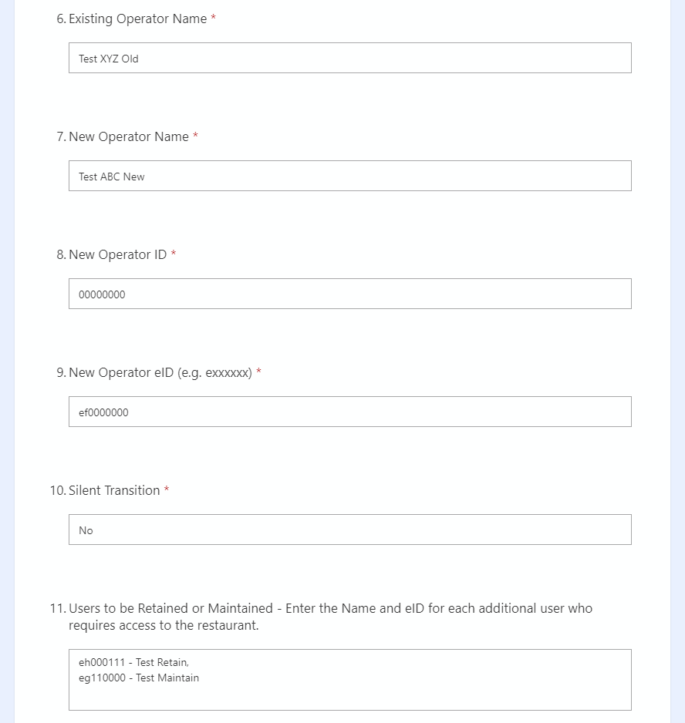

Fill if there is any “Other Information” and then Click “Submit” and Upon submission, we receive the information.

- Person with admin rights download the form share with the team in an Excel format. Below attached is the demo excel sheet.
- Admin defines the date when to schedule early access and go-live date changes and deployer do the changes as per the information.
- The identity of the person who fills out the form remains anonymous — we do not receive their name or employee ID.
- We do not begin work immediately upon receiving the form.
Instead, we wait for a confirmation email from the lead instructing us to proceed.

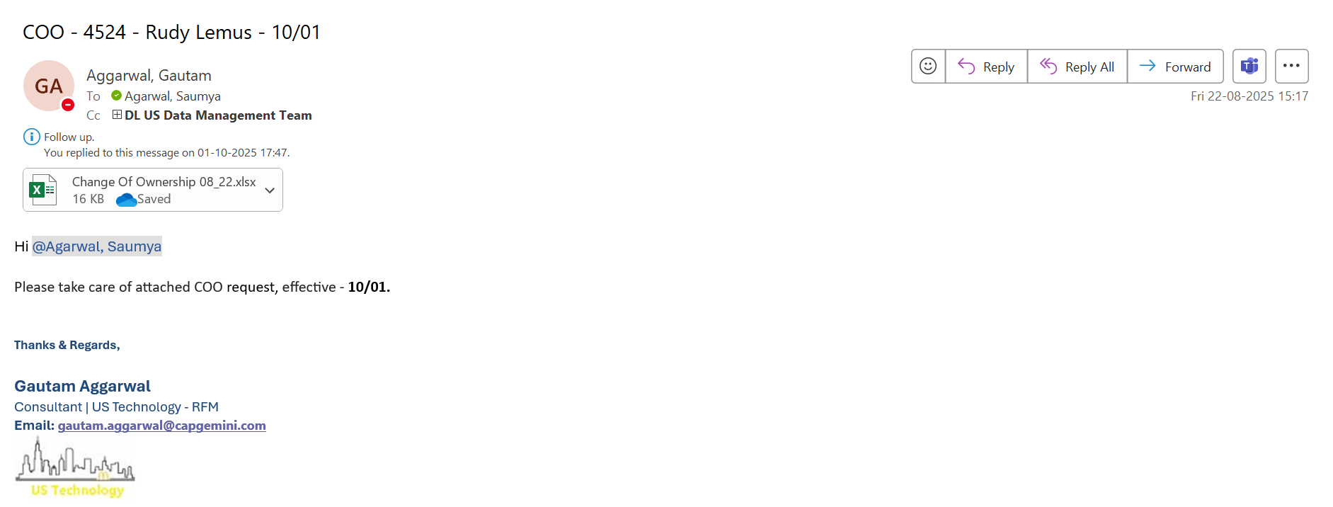

Types of Change of Ownership
Change of Ownership is of two types:
- Traditional Change of Ownership
- Silent Change of Ownership

Traditional Change of Ownership:
In the Traditional type of ownership, ownership is transferred from one person to another that can be unknown or known etc. In this COO we remove the OTHER users that already have access to the store, keeping in mind not to remove any OTM, retained/ maintained users and owner operator.
As you can see below is the Traditional COO form looks like:

Silent Change of Ownership:
In the Silent type of ownership, ownership is transferred from one person to another that will be within family members. In this COO we don’t remove the OTHER users that already have access to the store, we only give access to the owner operator and retained/ maintained users keeping in mind not to remove any OTM, retained/ maintained users and owner operator.
As you can see below is the Silent COO form looks
End – to – End Workflow:
Kindly follow the below steps for Change of Ownership process –
(Initial validation, email communication, OTM approval, trackers update, invites setup & deployment)
- Once you’re assigned with COO task, check the Store and Coop details in RFM. Check whether all the stores mentioned exist in RFM. Also, verify if all stores belong to same Coop or not.
- Check Eid of new Owner Operator and retained/maintained users in RFM Prod (provided in the survey).
- Verify if they already exist, or
- If not, get them added in LDAP (by raising a ticket on Service Café) – After OTM confirmation email only
Below attach is the format in which we send mail to LDAP Team to add user.
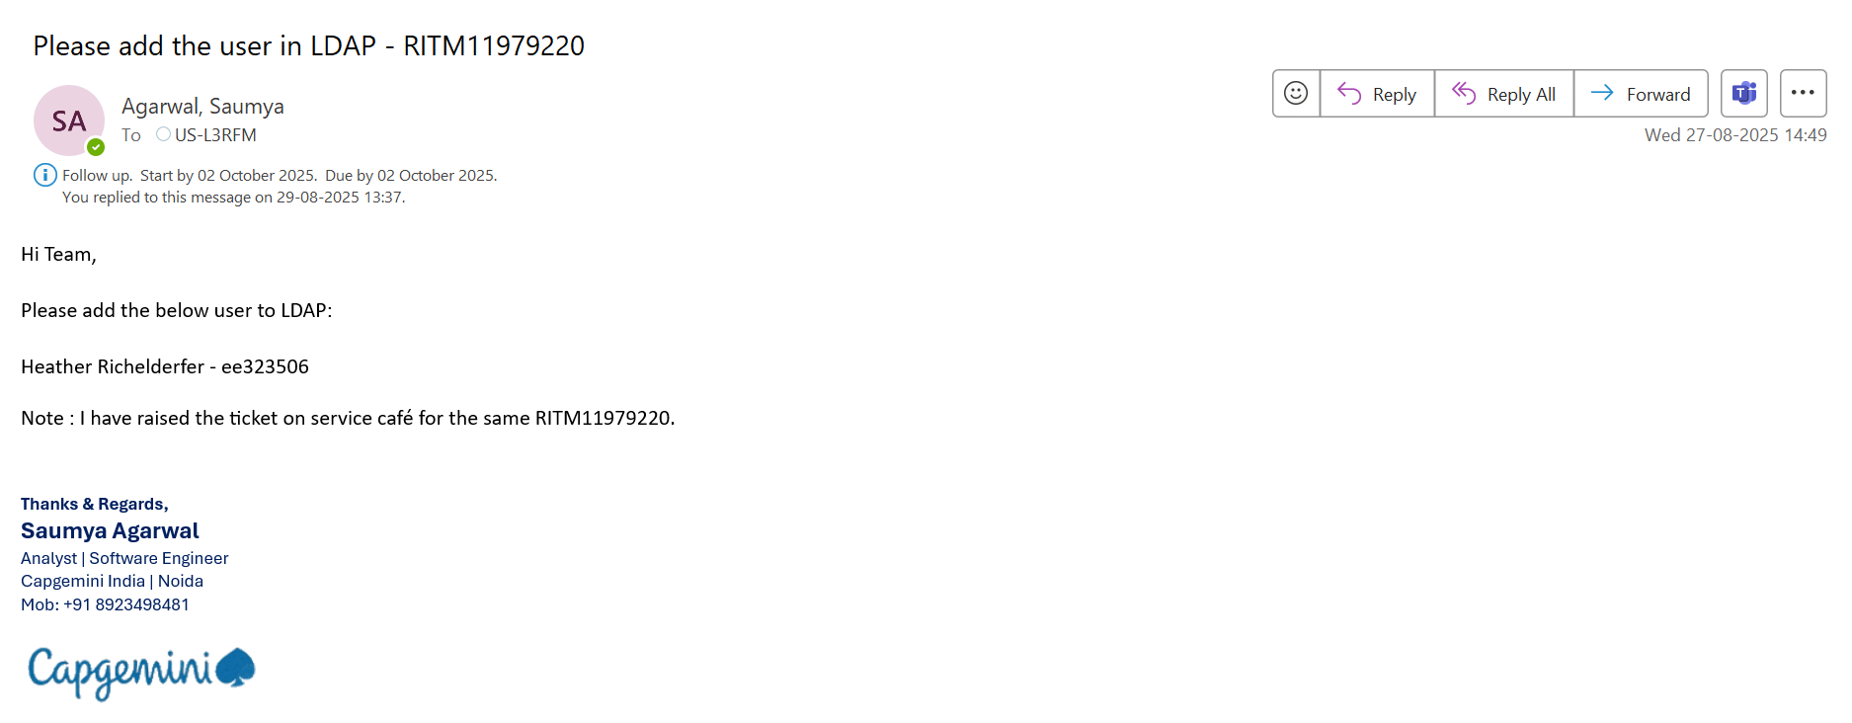
- Send an email to OTM for COO approval. (Keep US_PCS and Offshore DL in cc)
- Note: Send email to correct OTM only – Check Coop# of stores in RFM and then corresponding to it select the OTM from the updated “OTM_STIM list” (List attached).
- Below attached is the format in which we send mail to OTM for COO confirmation
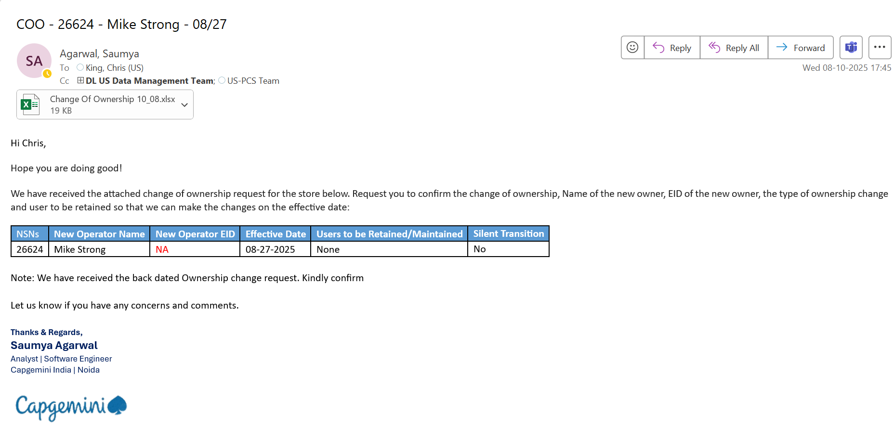
Content in text:
Hi [OTM Name],
Hope you are doing good!
We have received the attached change of ownership request for the store below. Request you to confirm the change of ownership, Name of the new owner, EID of the new owner, the type of ownership change and user to be retained so that we can make the changes on the effective date:
NSNs | New Operator Name | New Operator EID | Effective Date | Users to be Retained/Maintained | Silent Transition
Let us know if you have any concerns and comments.
- Update Ownership tracker with correct details & comments.
Link:  Ownership Change Tracker.xlsx
Note:
- Person assigning you the COO task will update the COO entry in Daily Task tracker (on your behalf) but you’ll have to keep updating the status/comment in the tracker(timely).
- If the COO is “Silent” – You will update the COO entry in Daily Task Tracker likewise.
- Setup the calendar invite for early access & performing date of COO.

- Post OTM confirmation, setup an invite/reminder(s) for “Early access” and “Go-Live” date for our DL only. Attach survey & OTM confirmation email in the same invite.
- Note: Early access date will be at least 5 days prior to go-live date of COO.
- Provide Early access to new O/O & retained/maintained users on the date mentioned in the tracker & invites. And send email to OTM, confirming early access given to users (attach screenshots as well).
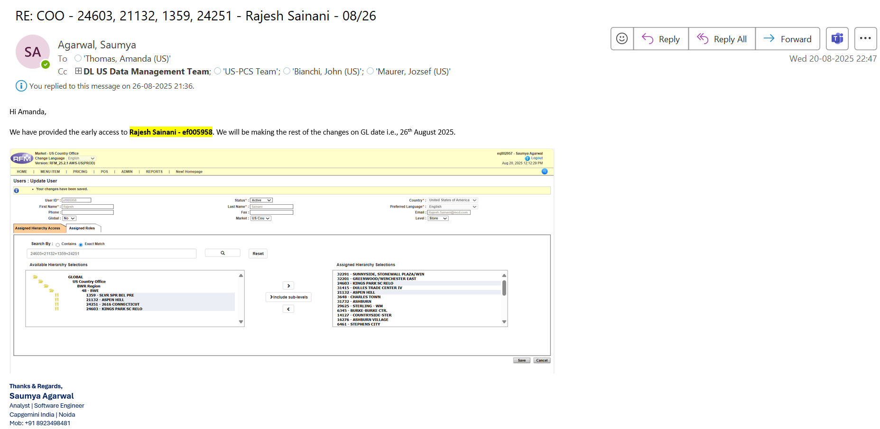
- On the Go-Live date, deploy the COO in RFM Prod and send for validation with all the screenshots in word file.
- Post P2P validation, send the final completion email to the OTM on the same email where we have confirmed the early access part. Attach COO survey and latest GAM file (attached the file below) while sending an email (attached).
- Note: Follow below provided email format only in case both cases - “Traditional” & “Silent” COOs.
- Update Daily Task Tracker with the completion remarks.
- Also, update the Ownership Tracker and move the entry to completed tab.

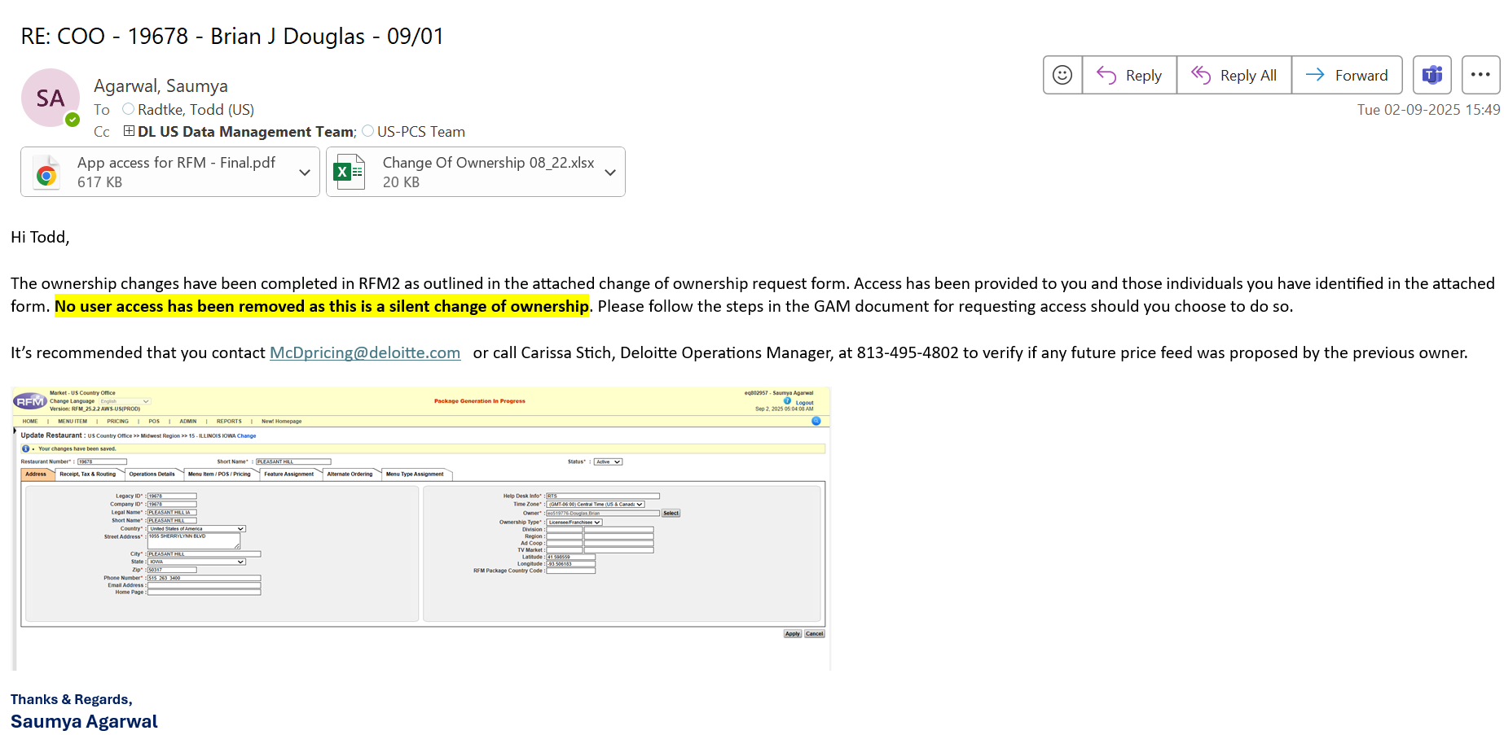
Early access
What is early access?
We provide new user access so that they have store access.
Why we give early access?
We give early access so that they do not face any kind of problem during transition period
When do we provide early access?
We usually provide early access 5 days prior to the go-live date.
Procedure to provide early access to Silent/Traditional COO is the same.
Below are the steps:
First, go to ADMIN > Users.
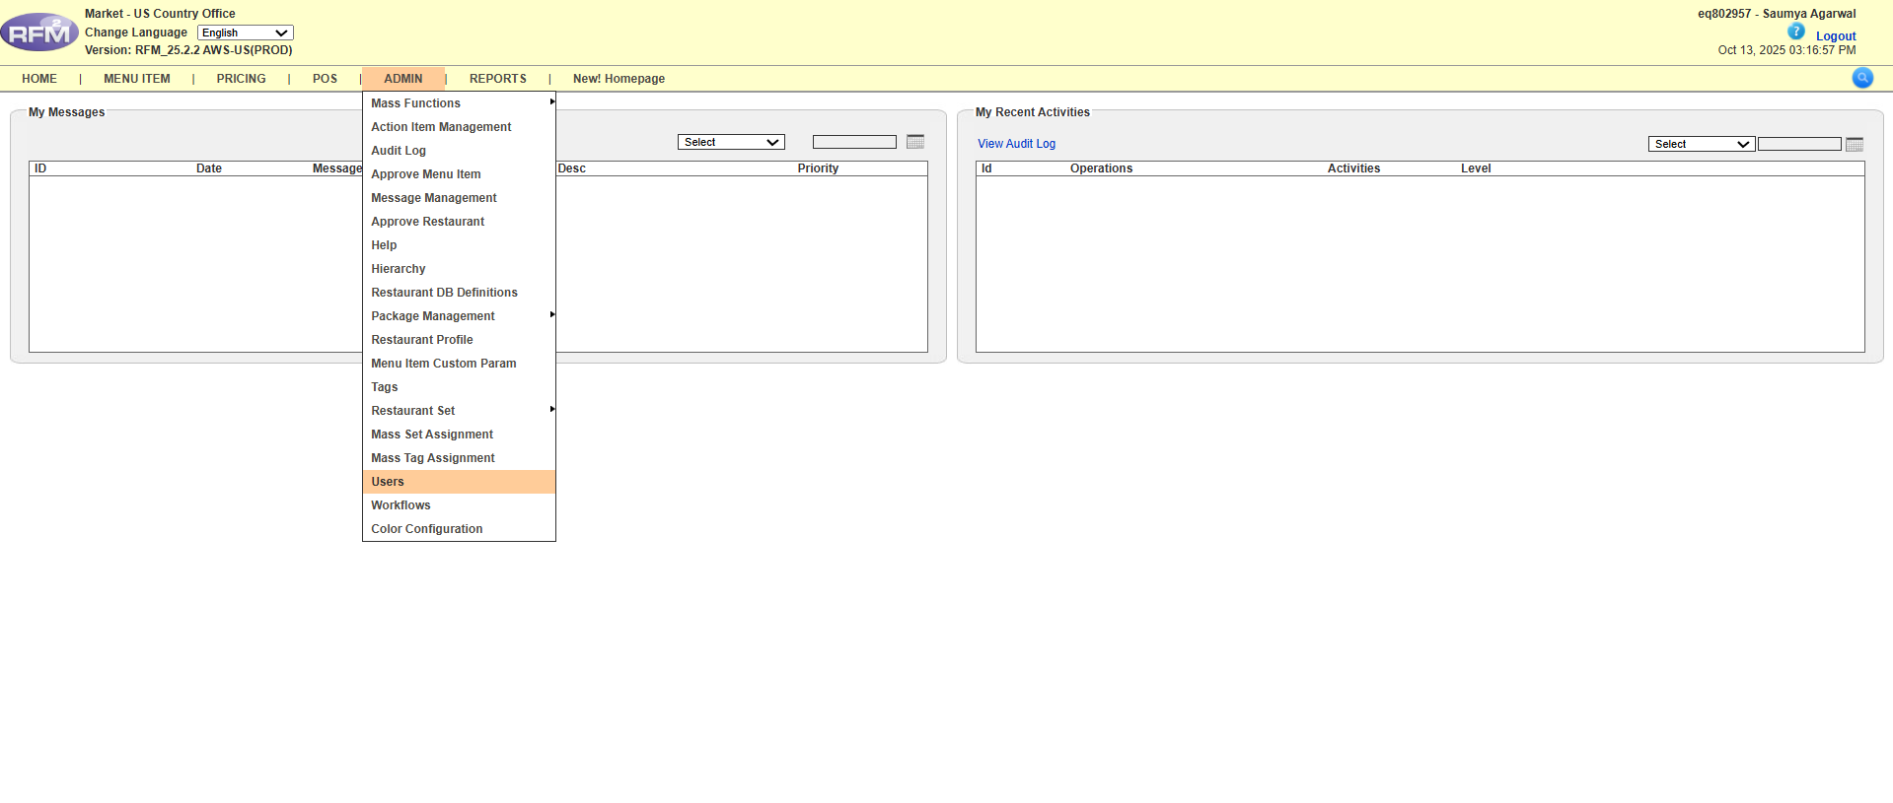
Now, provide store access to the new operator and the users to be retained, as mentioned in the Survey/OTM Confirmation email.
Search the eIDs.
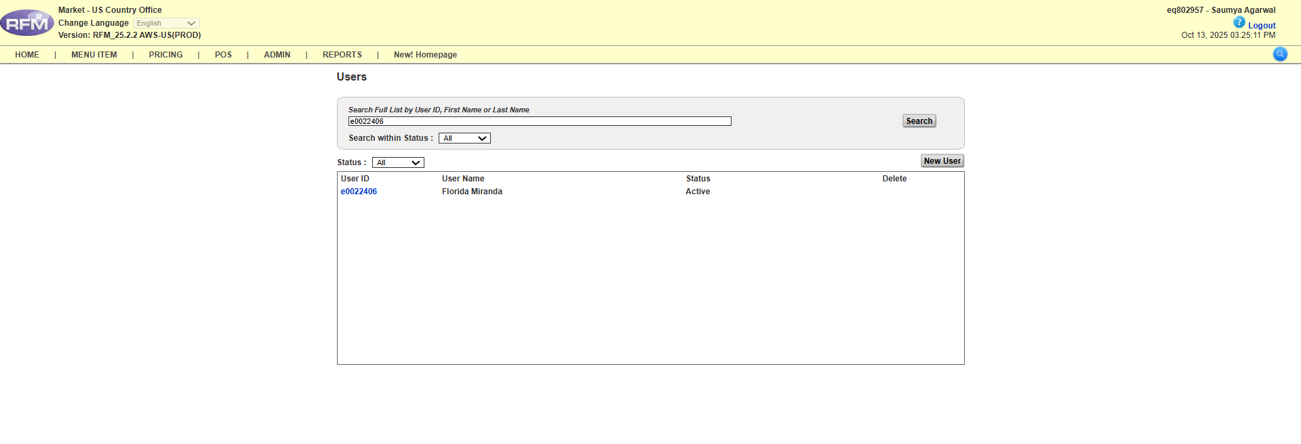
Search the store number using an exact match, select the store, move it to the right, and click on “Save”.
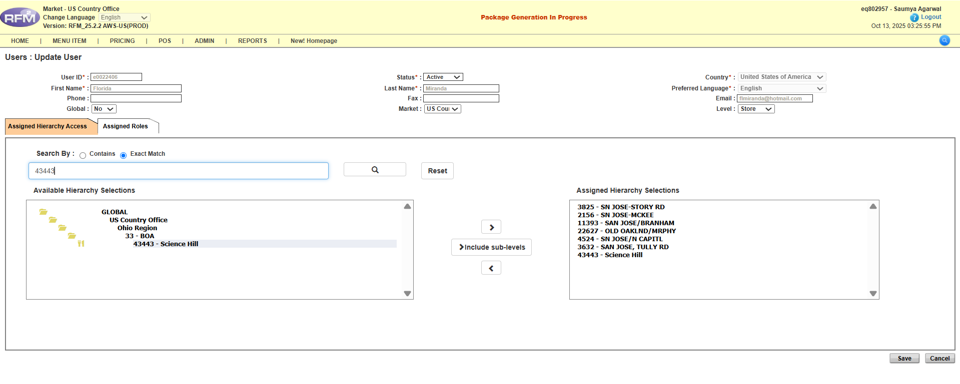
Repeat the above steps for all users to be retained and new operators for all the stores mentioned in the Survey/OTM Confirmation email.
Email communication after providing the early access
After completing above steps, confirm to OTM that you have provided early access to the user for the respective store. Also, inform them that the remaining changes will be made on the go-live date.
Below is the early access email format. Attach the RFM screen showing the user access for the respective store.
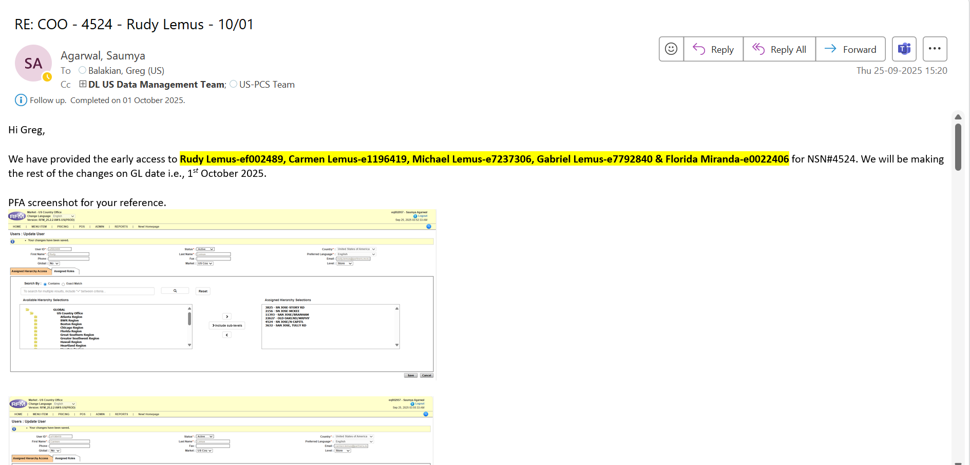
Go-Live date Changes (Performing)
What do you mean by go-live date changes?
We remove the existing owner operator access to the store and provide it to the new user so that they have store access and handle all the things.
Why do we perform the COO?
We perform the COO so that no previous existing user has access to the store going forward. Only the retained user and the new user have access.
When do we perform the COO?
We usually perform the COO on the go-live date.
Procedure to perform Silent/Traditional COO is different.
Below are the steps:
Traditional COO Process: In Traditional COO, we remove the existing user access for the store.
First, go to ADMIN.
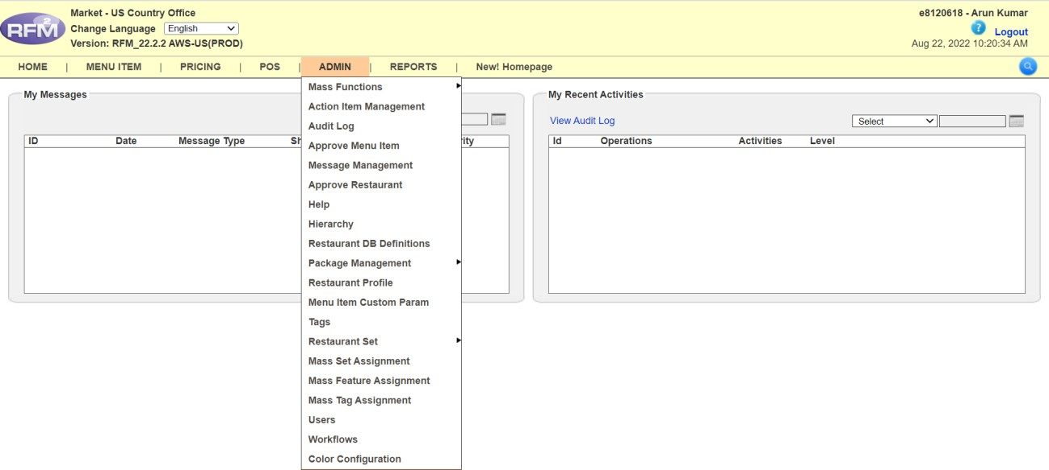
Click on Restaurant Profile.
Then type the STORE NUMBER in the search bar and click on EXACT MATCH.
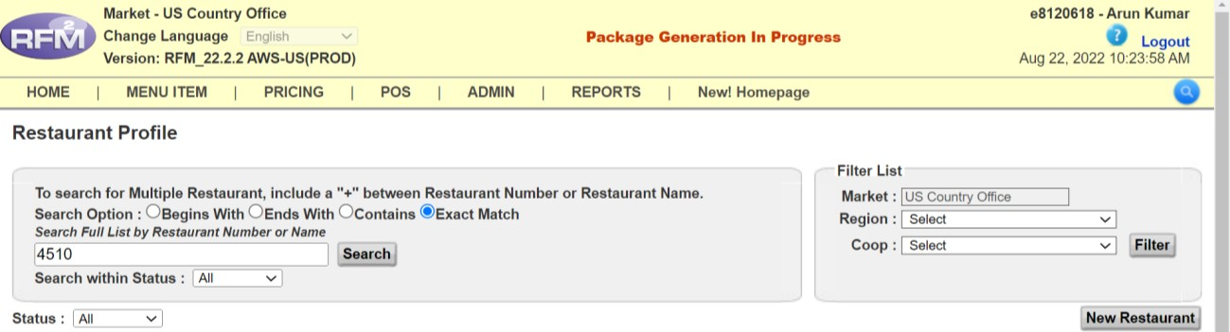

Click on SEARCH.
This will display the desired store you are searching for.
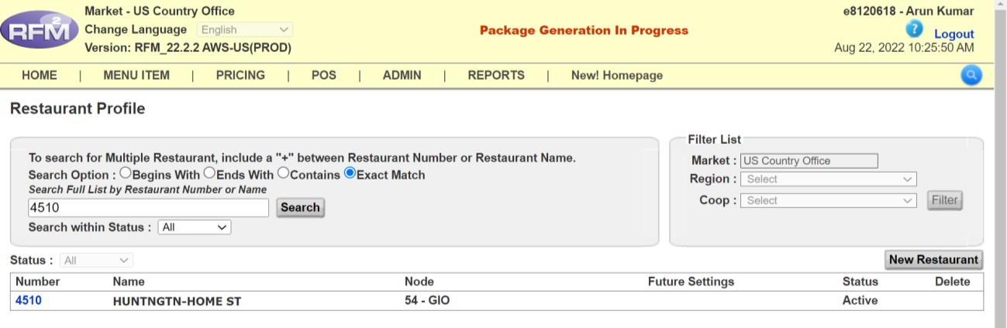
Select the store.
A new window will open.
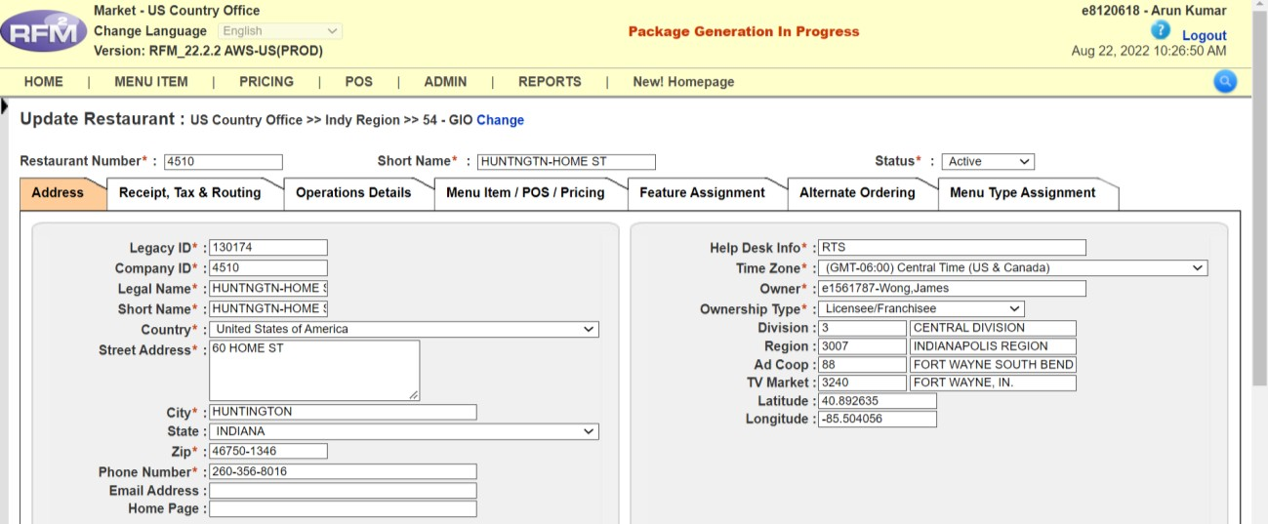

In the OWNERSHIP TYPE dropdown, select COMPANY OWNED.
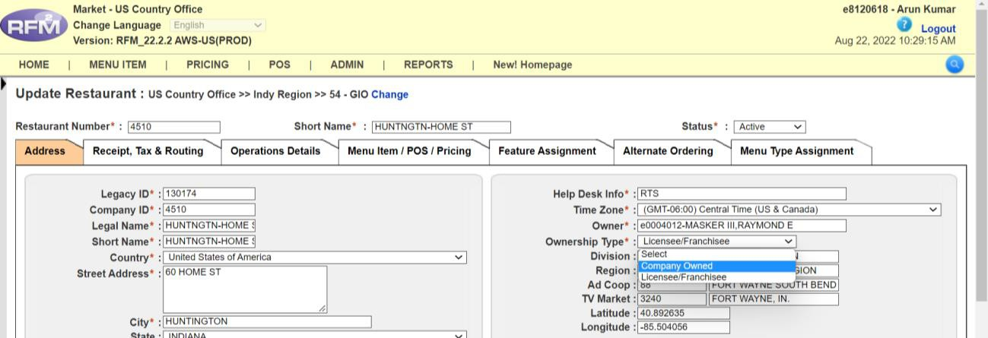

Then again in the same dropdown, select LICENSEE/FRANCHISE.
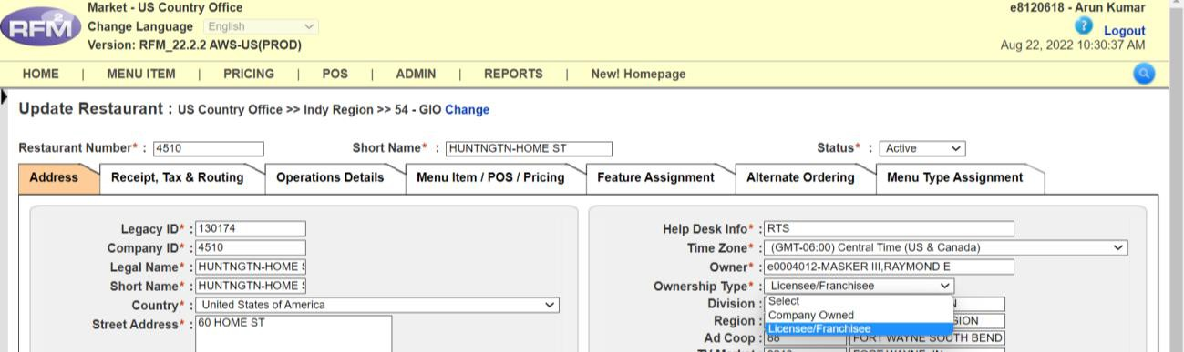

Click on SELECT.
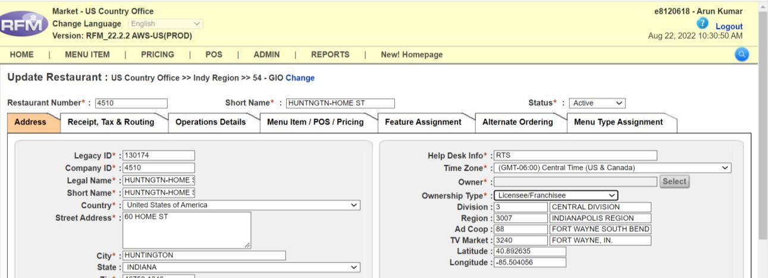

A pop-up will open. Enter the E.ID of the NEW USER.
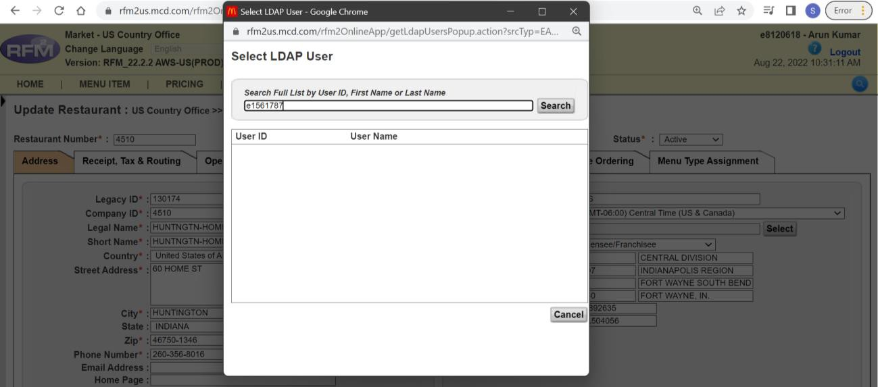

The result will appear. Select the first entry that matches the E.ID.
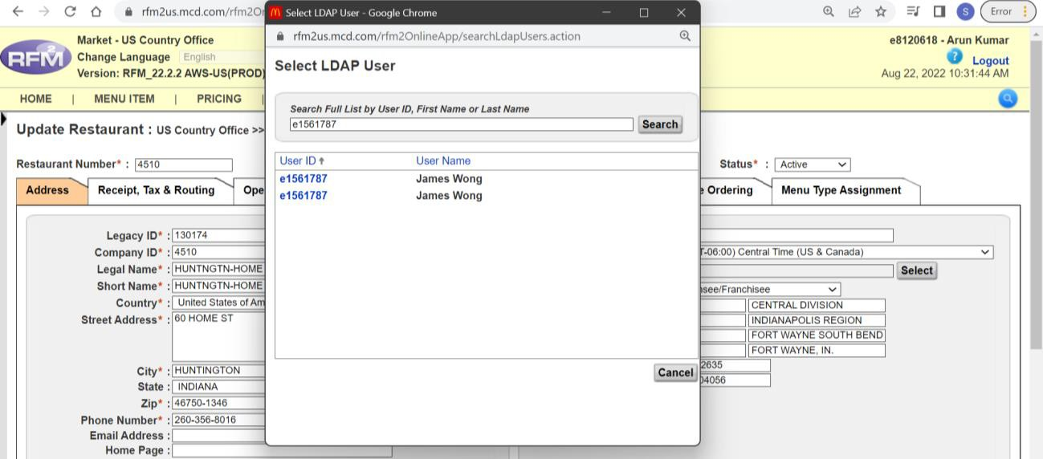

In this step, we are GIVING ACCESS TO THE NEW OWNER.
Click on Apply. Once the changes are made, a yellow bar will appear saying:
"Your changes have been saved."
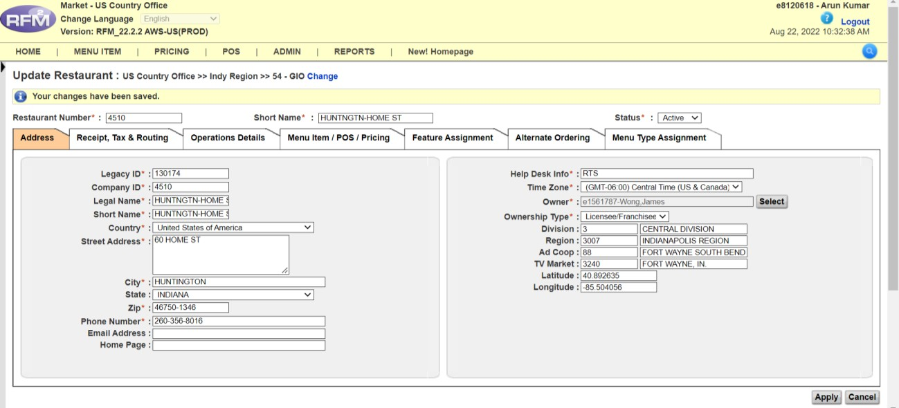
If you do not find the user in the list, you will need to enter it manually using the correct naming convention:
[eID-lastName,FirstName MiddleName]
example: If Eid: e0006426 and Username is: Luna Llanes Roberto
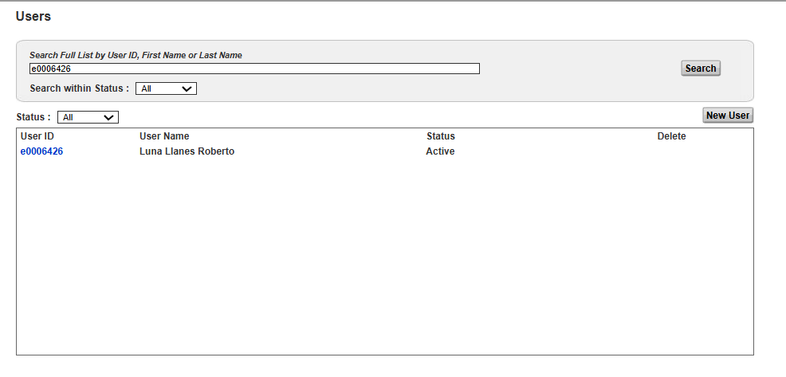

Format to write E.ID:
Example: e0006426-Roberto,Luna Llanes
Click on USERS.

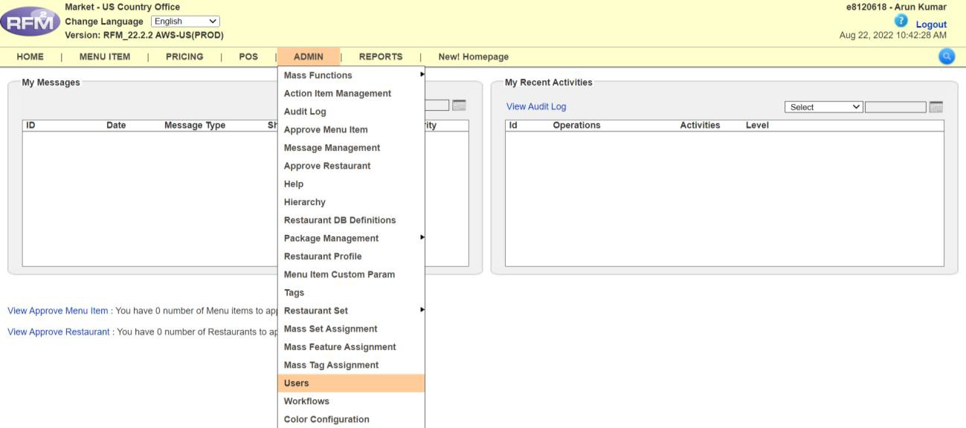

A new window will open.

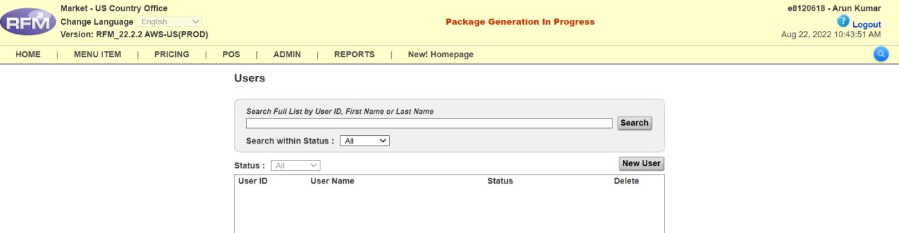
Type the E.ID of the NEW OWNER OPERATOR.
If not found, click on New User and enter the same E.ID.
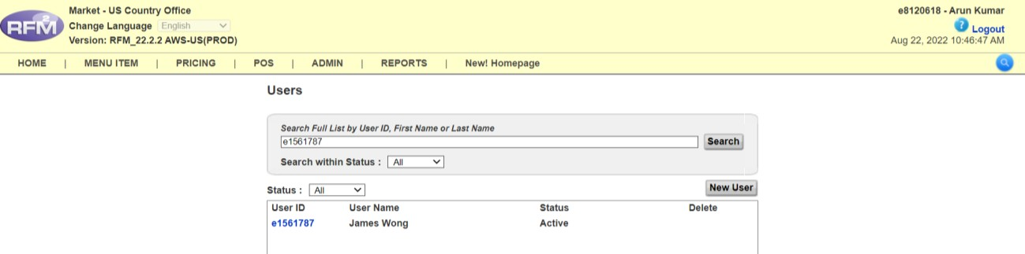

Click on the E.ID of the NEW OWNER.
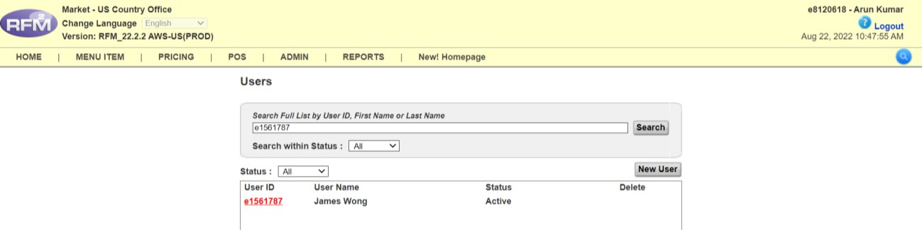

Type the STORE NUMBER in the search box, click on EXACT MATCH, then click Search
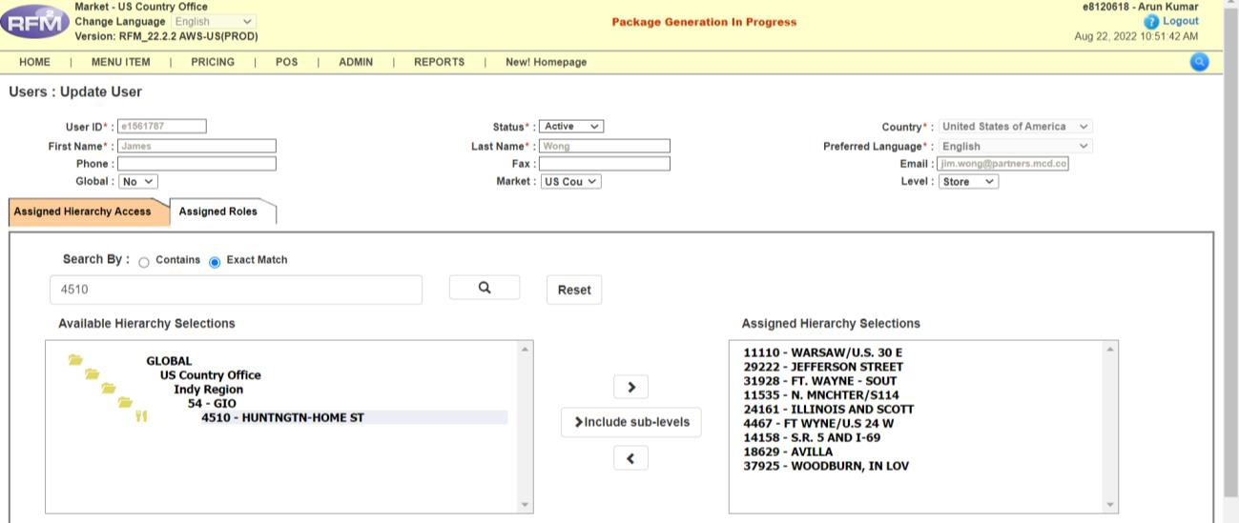

Move the store number from LEFT to RIGHT so that the user gets access to the store.
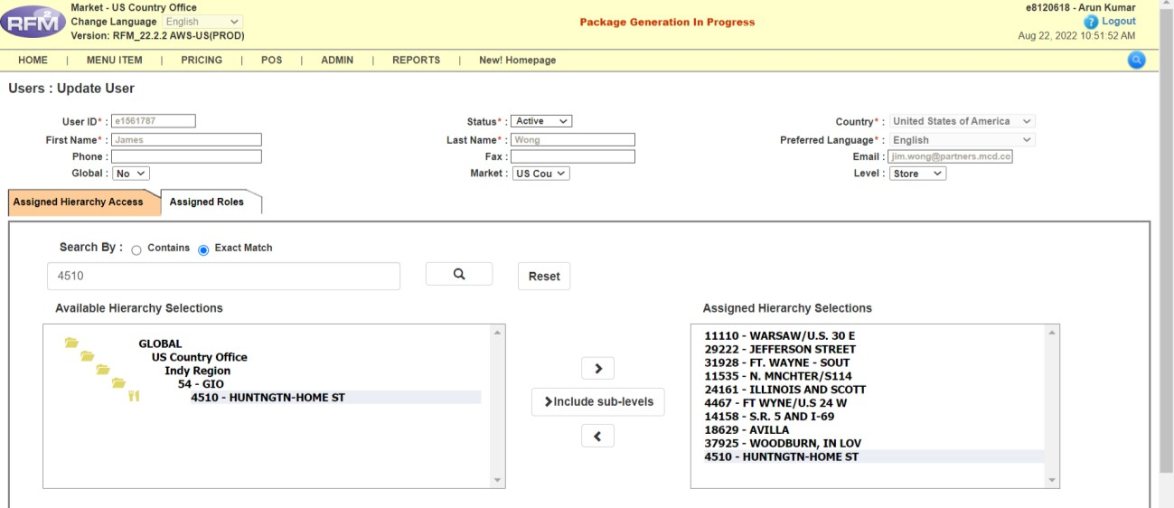

Click on SAVE.
A yellow bar will appear saying:
"Your changes have been saved."
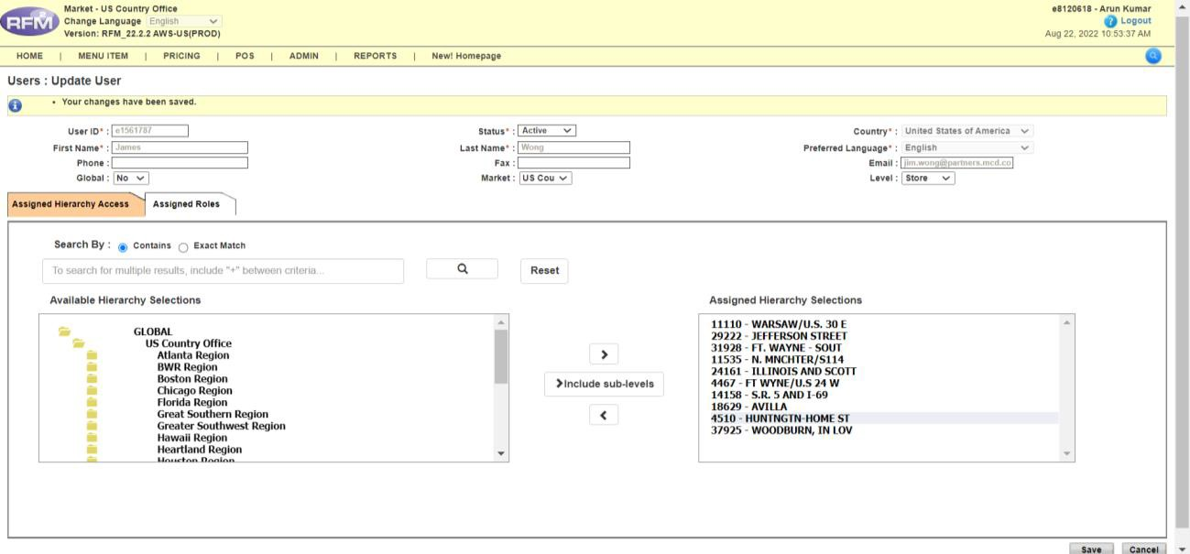
Now, remove other users.
Generate a report called Access Control Report by Node.
Go to:
REPORTS TAB >> ACCESS CONTROL >> BY NODE

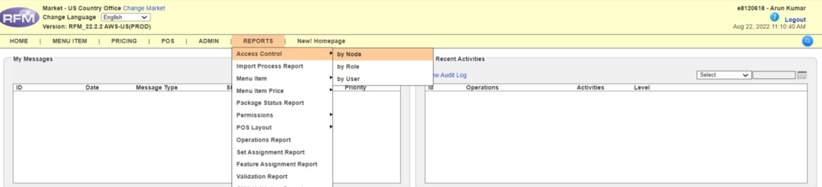

Type the STORE NUMBER in the search box, click on EXACT MATCH, then click Search.
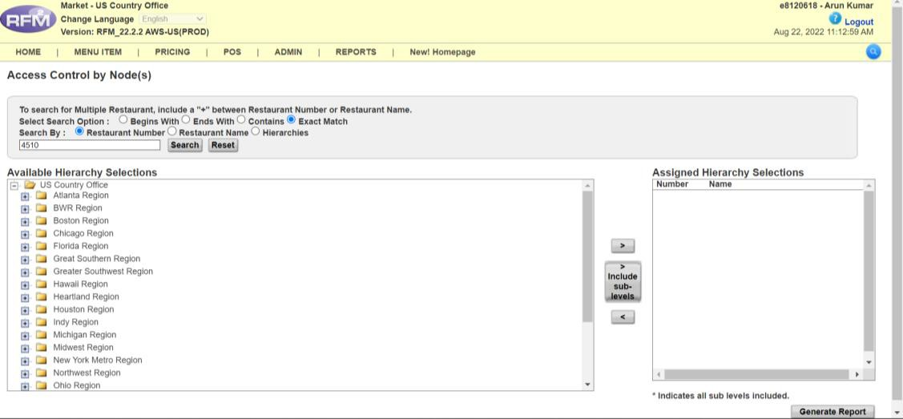

Move the store number from LEFT to RIGHT, then click on Generate Report.
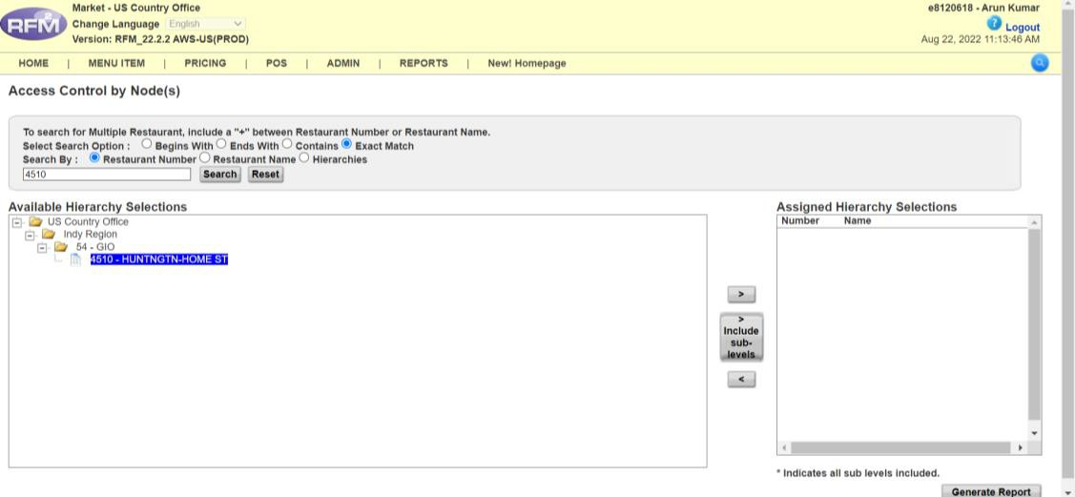
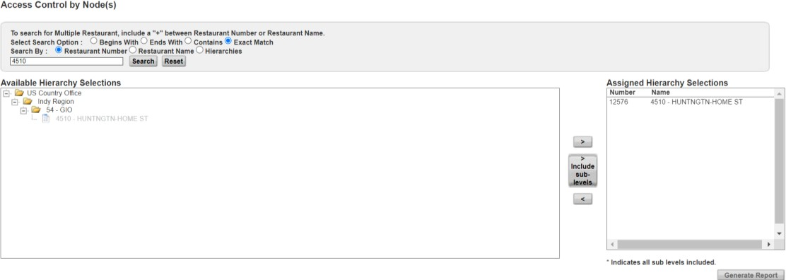

Click on SAVE AS CSV.
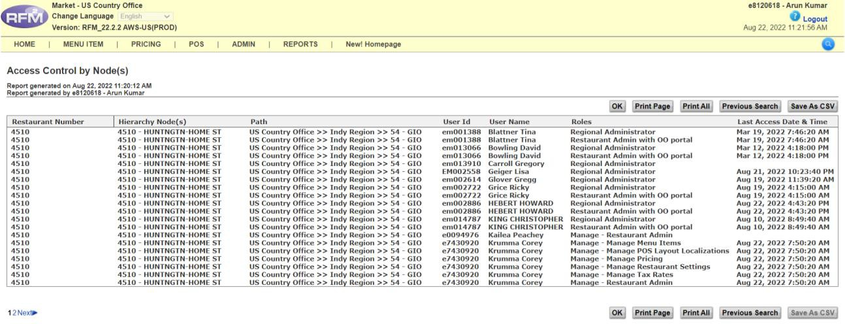
Now remove OTHER USERS.
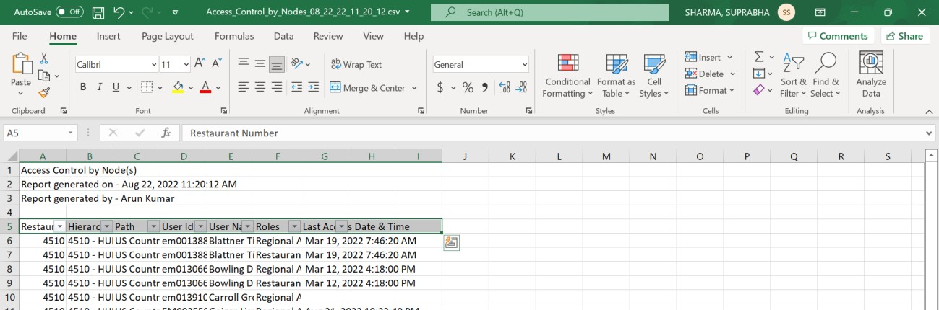
Press CTRL+SHIFT+L to filter the data.
In the dropdown, unselect all and only select: MANAGE – RESTAURANT ADMIN
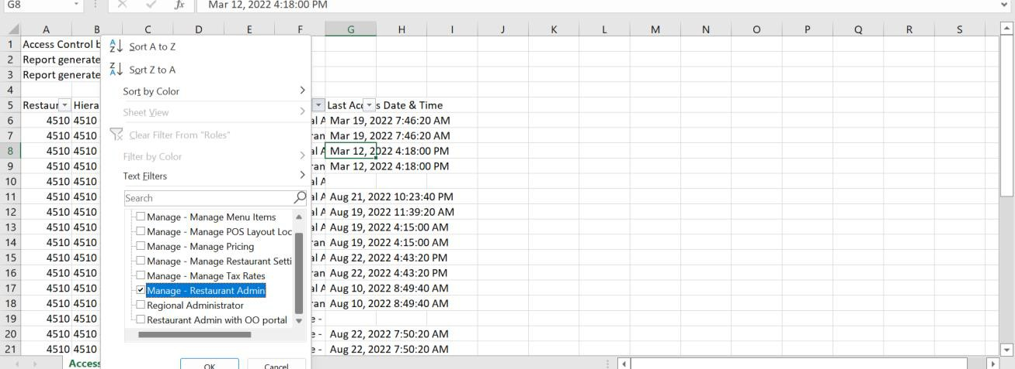

NOTE:
Do not remove any OTM, RETAINED/MAINTAINED USERS, or OWNER OPERATOR.
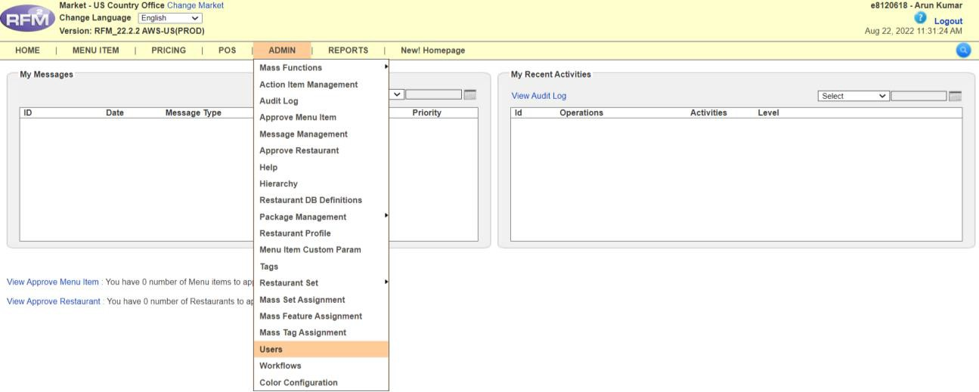

To remove access of a user:
Paste the E.ID in the search box and click on the Search tab.
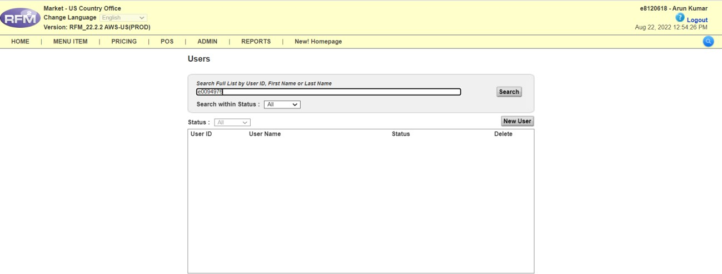
Click on the E.ID.
A new page will open.
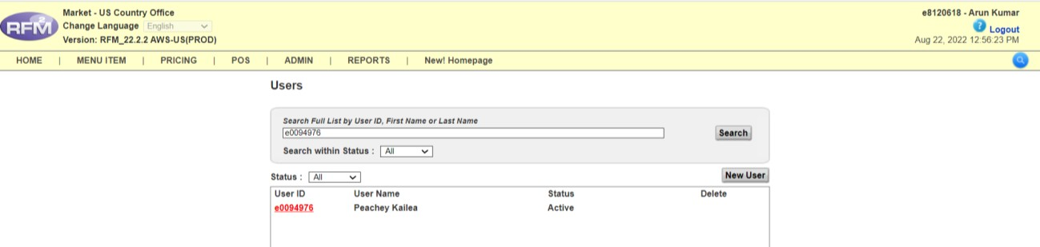

Check the access level.
If the level is “Store”, proceed to remove access.
If the level is “Coop” or “Region”, do not make any changes.
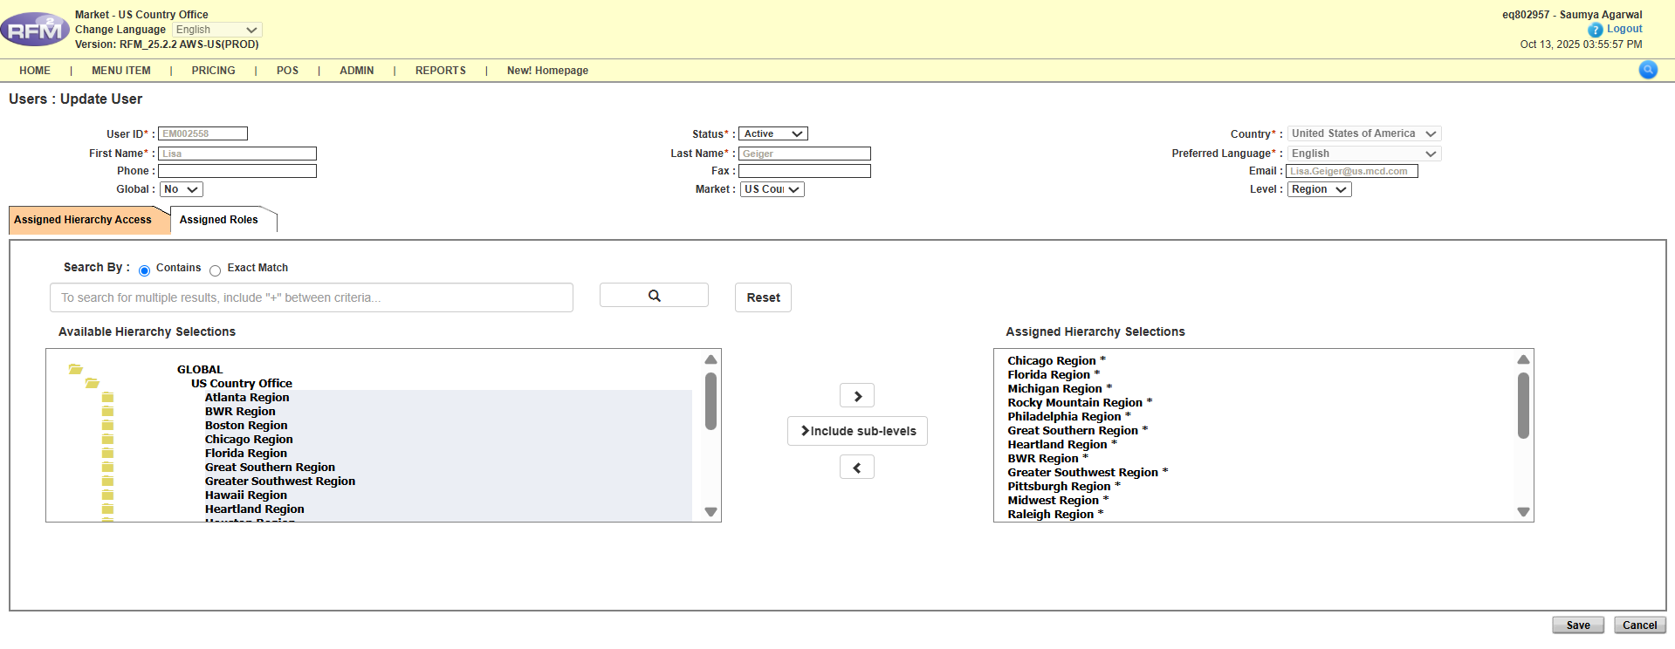If the level is “Store”, follow these steps based on the number of store accesses:
1)If the user has only one store access:
You cannot remove the store directly, as RFM will show:
“Please assign at least one Node to the user”
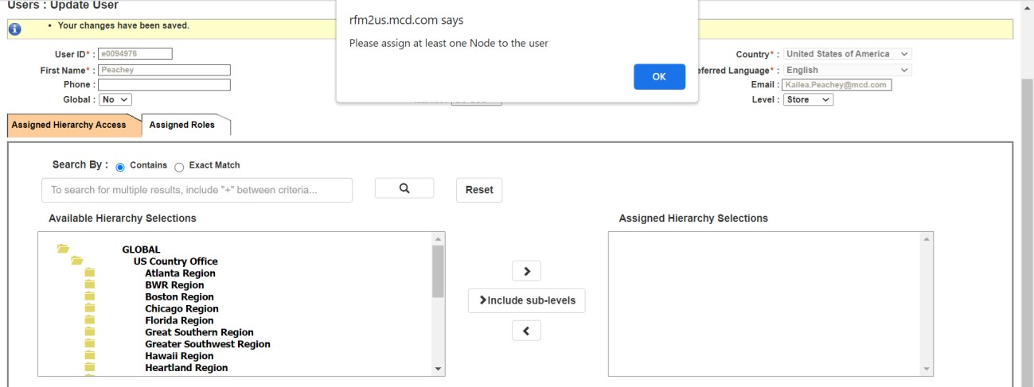

So, make the user INACTIVE:
- Select the STATUS dropdown
- Choose INACTIVE
- Click SAVE
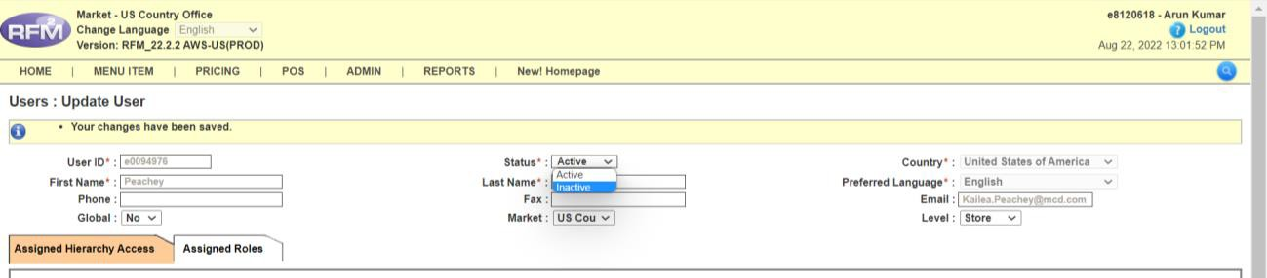

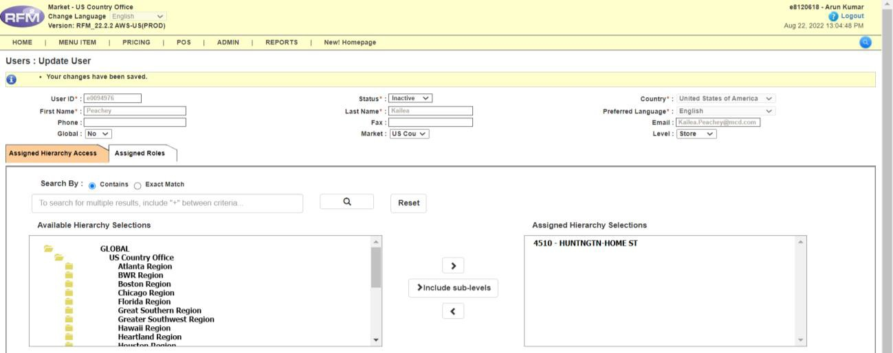
2) If the user has more than one store access:
Select the store to be removed
Move it from RIGHT to LEFT
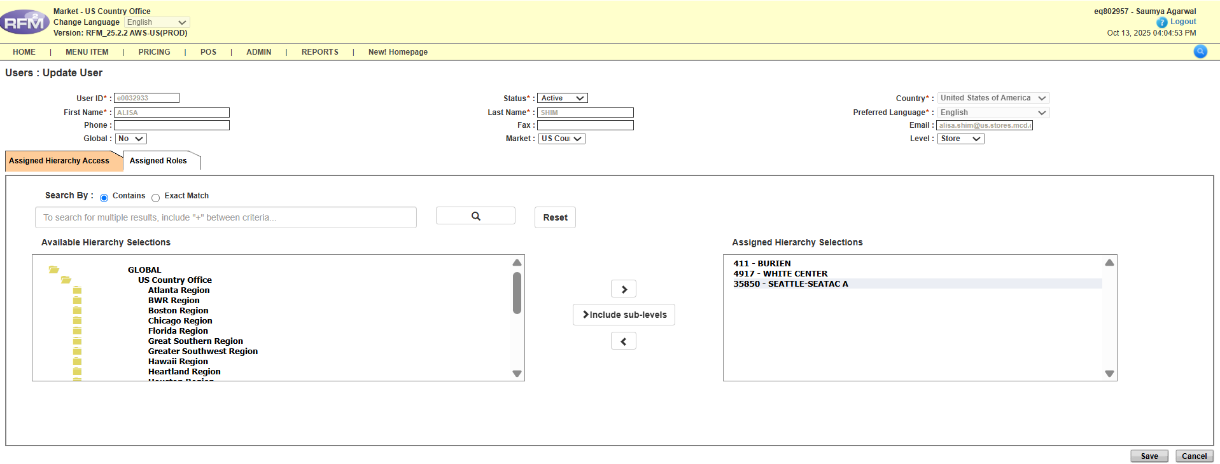
Click SAVE
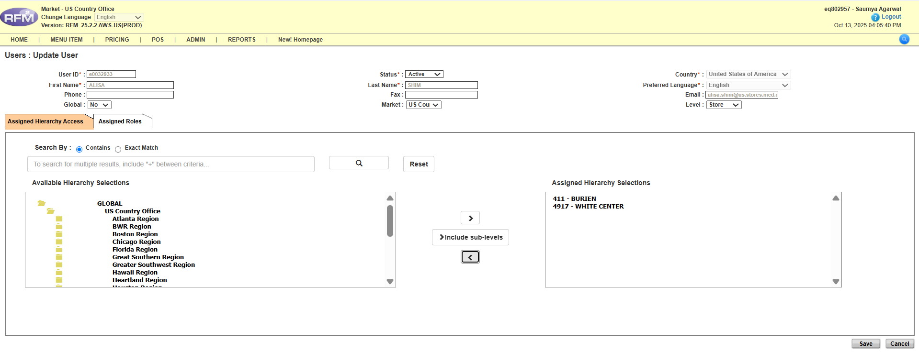
Silent COO Process:
In Silent COO, we do not remove existing user access for the store.
Go to ADMIN, then click on Restaurant Profile.
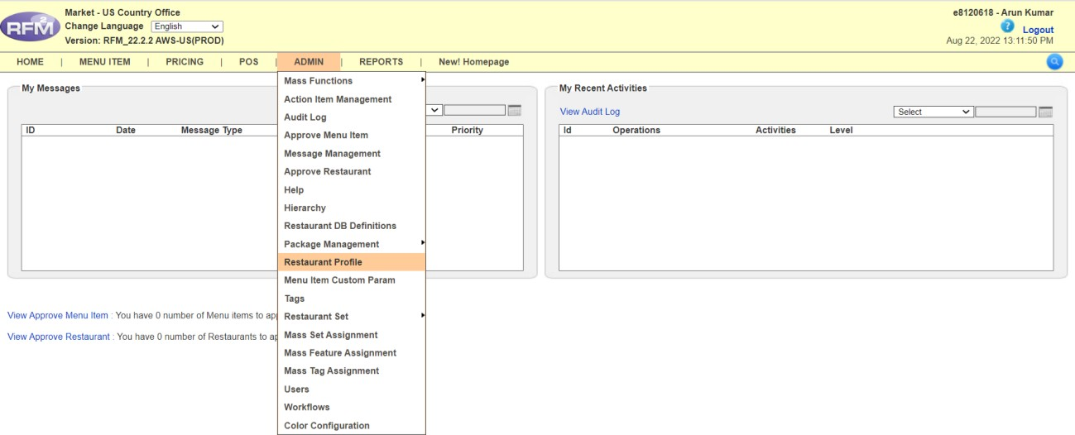
Type STORE NUMBER (e.g., 26642) in the search bar, click on EXACT MATCH.
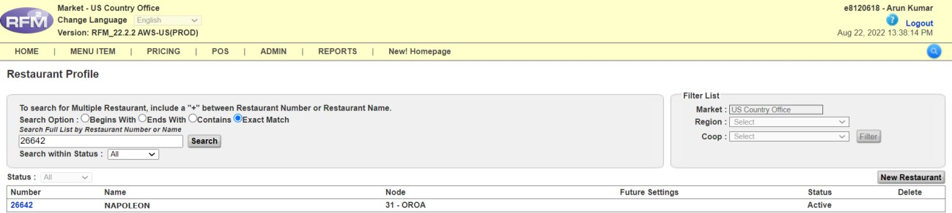
Select the store. A new window will open.
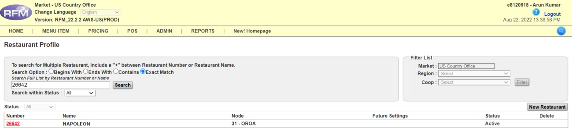

In the OWNERSHIP TYPE dropdown, select COMPANY OWNED.
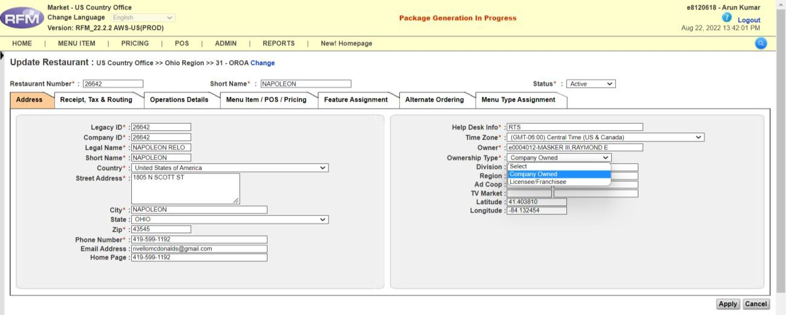

Then again in the same dropdown, select LICENSEE/FRANCHISE.
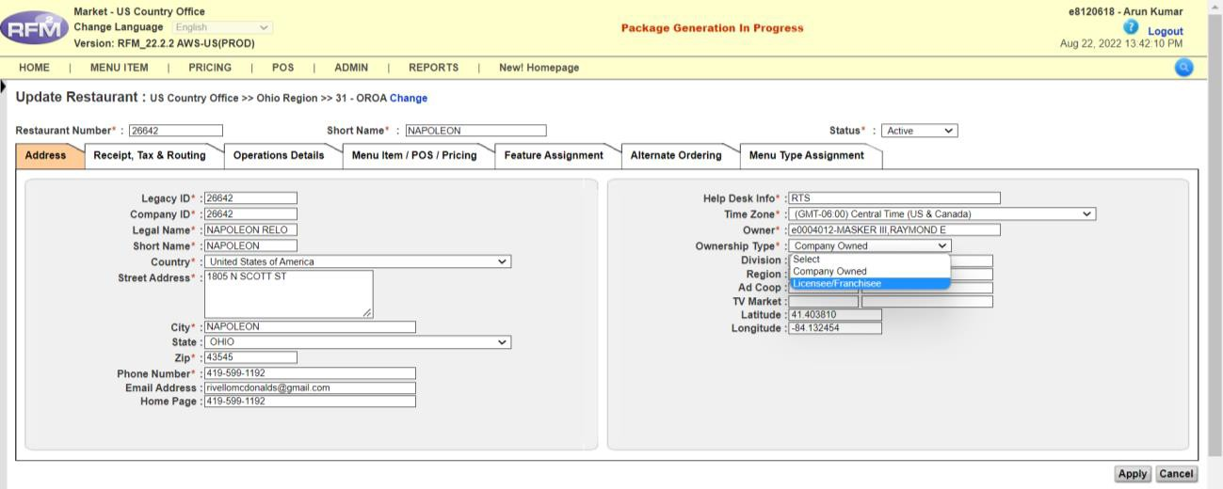

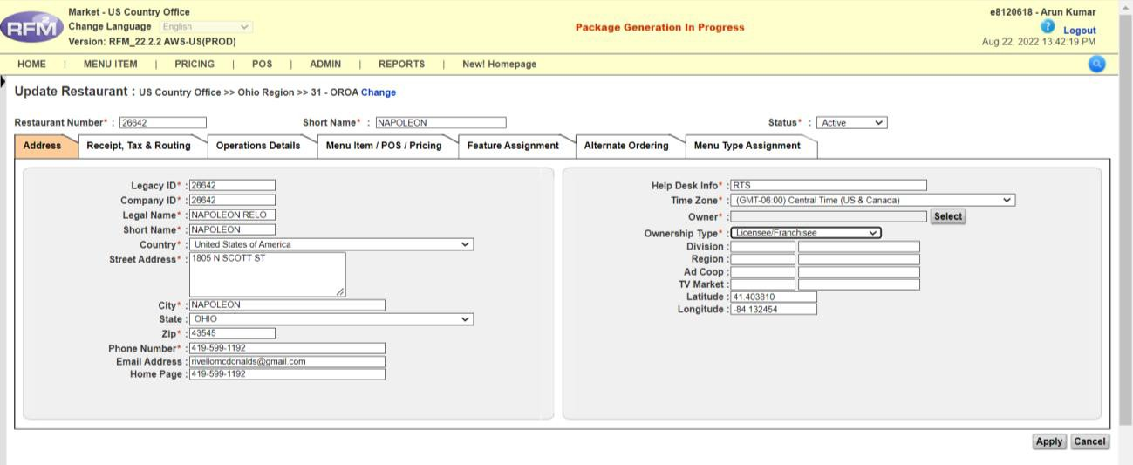
Click on SELECT.

A pop-up will open. Enter the E.ID of the NEW USER.
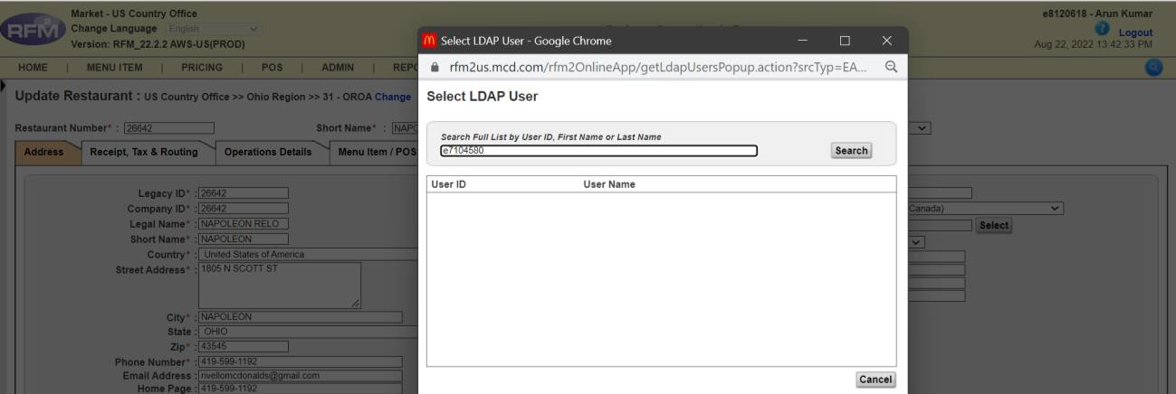

Select the first result that matches the E.ID.
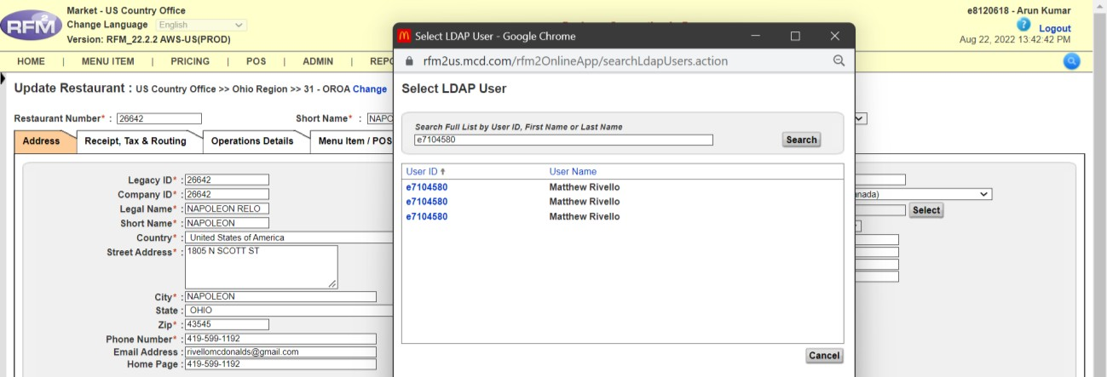

This step gives access to the NEW OWNER.
Click Apply. A yellow bar will appear saying:
"Your changes have been saved."
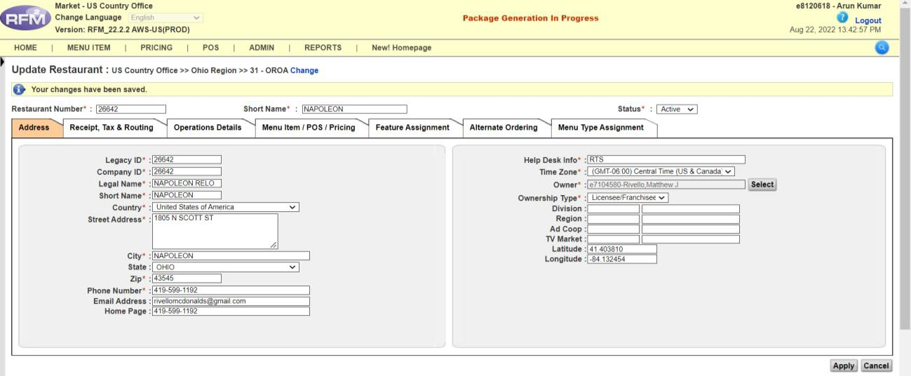

Click on USERS.
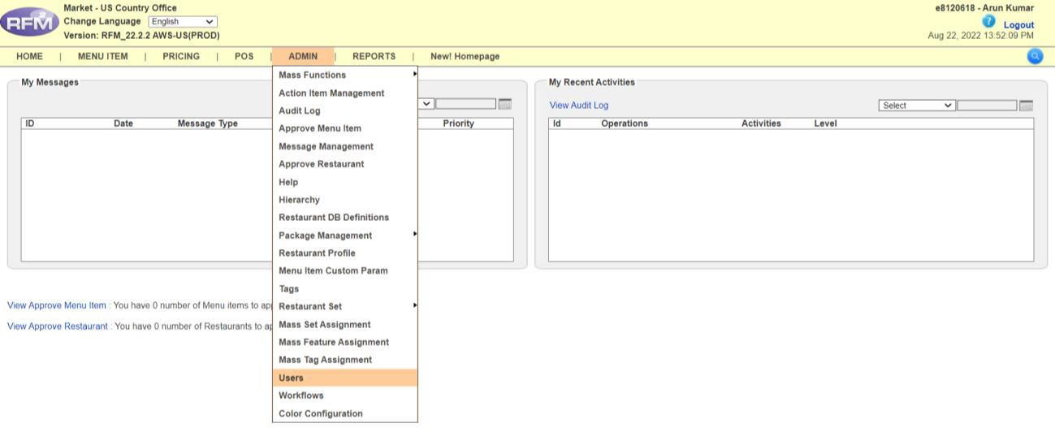

A new window will open.
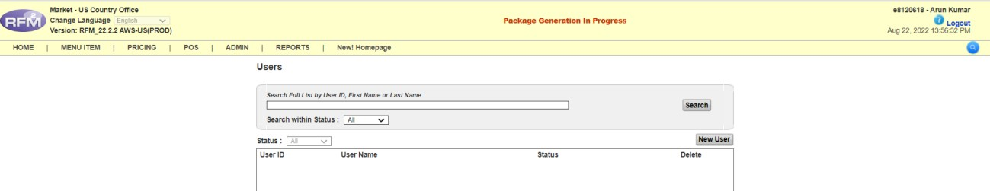
Type the E.ID of the NEW OWNER OPERATOR.
If not found, click on New User and enter the same E.ID.
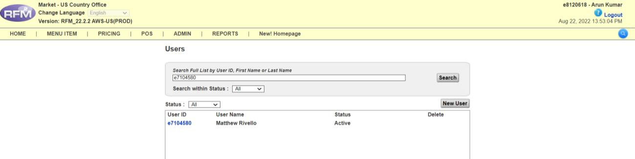

Click on the E.ID of the NEW OWNER.
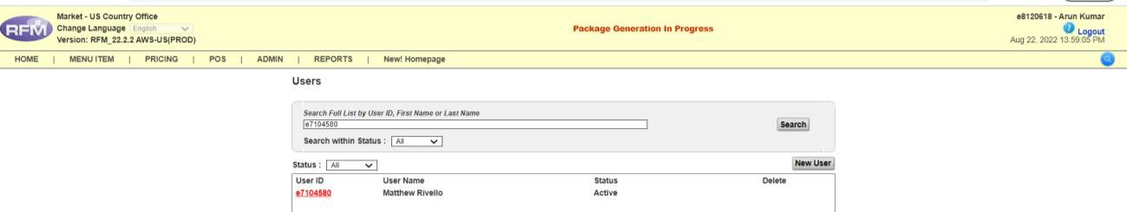

Type the STORE NUMBER in the Search Box and click on EXACT MATCH then Search:
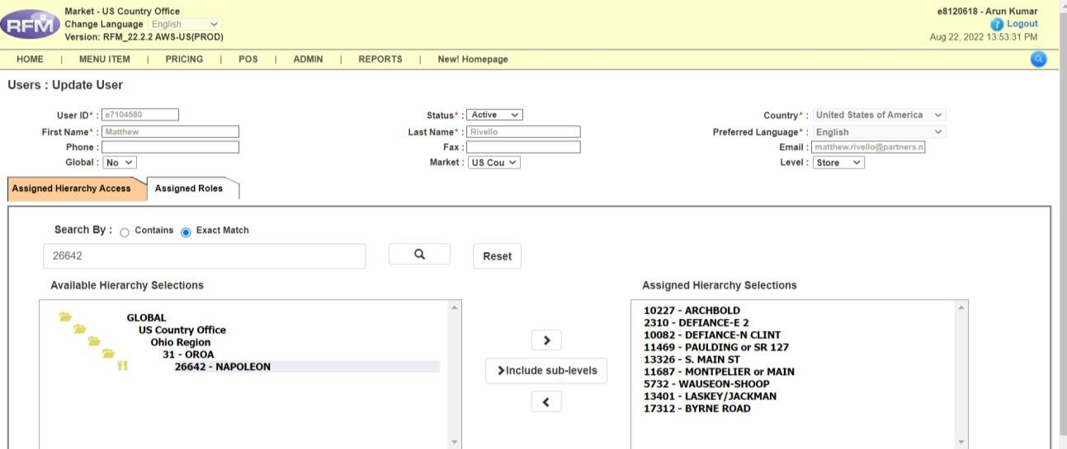
Move the store number from LEFT to RIGHT to give store access.
Click SAVE. A yellow bar will appear saying:
"Your changes have been saved."
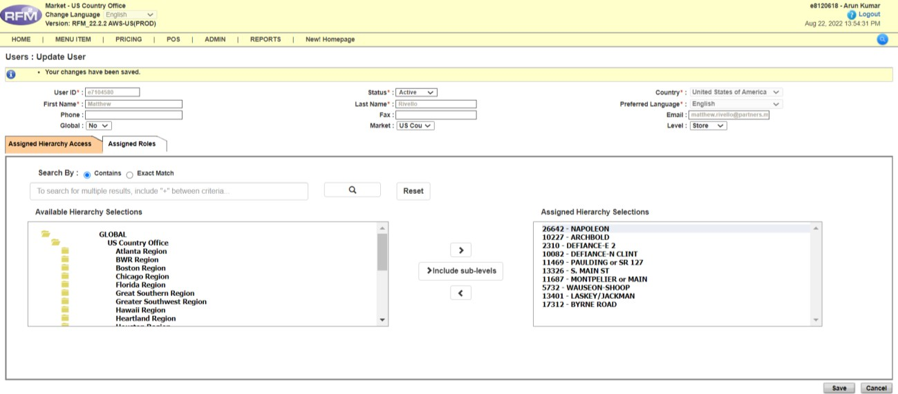

`

Giving Access to Retained/Maintained Users
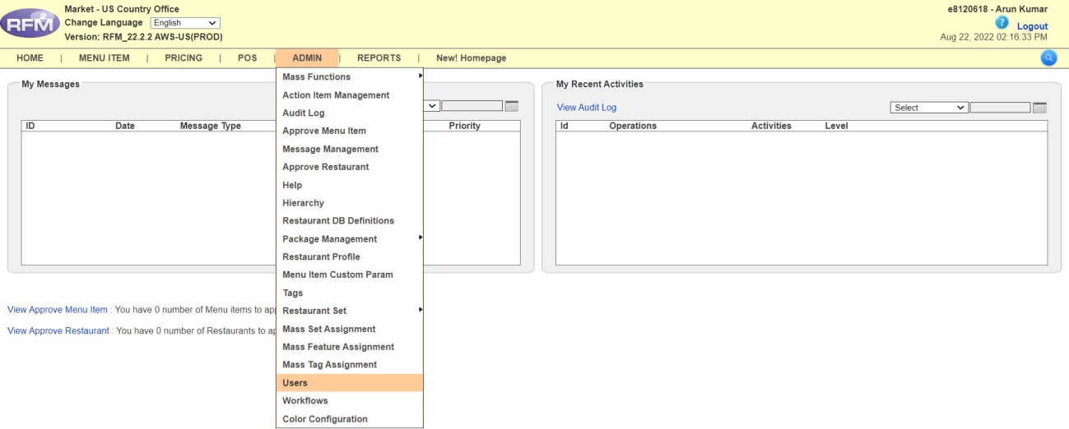
Click on USERS.
A new window will open.
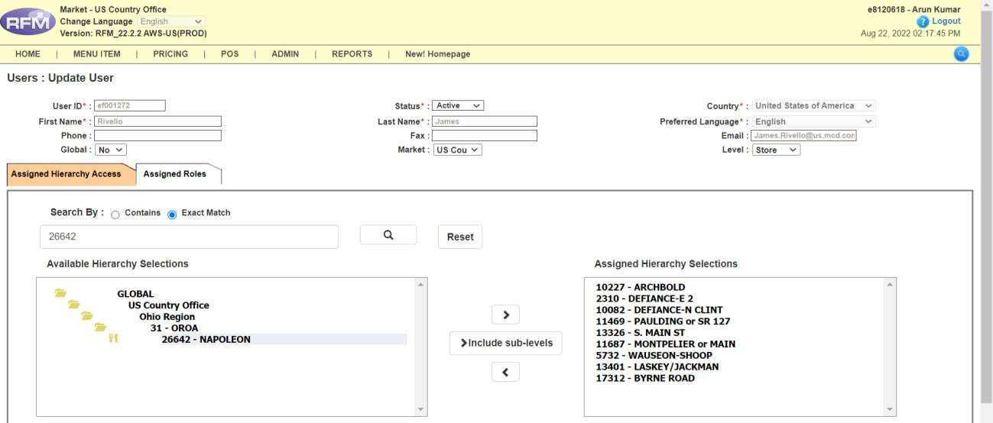
Type the STORE NUMBER in the search box, click on EXACT MATCH.
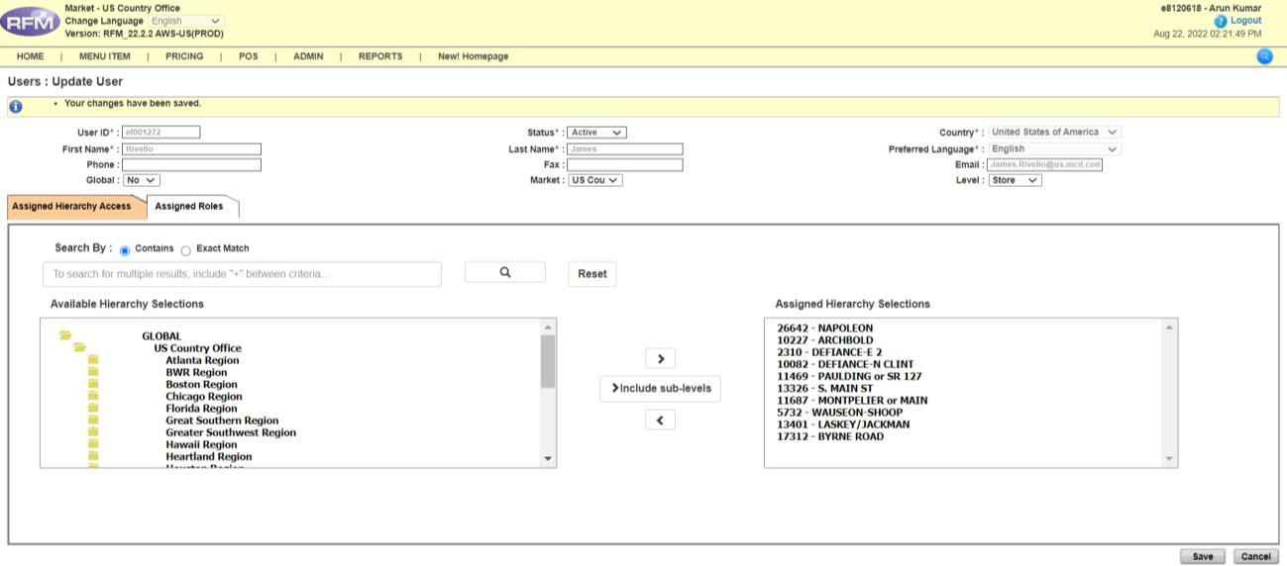

Move the store number from LEFT to RIGHT, then click SAVE.
Repeat the same steps for another user who is also Retained/Maintained.
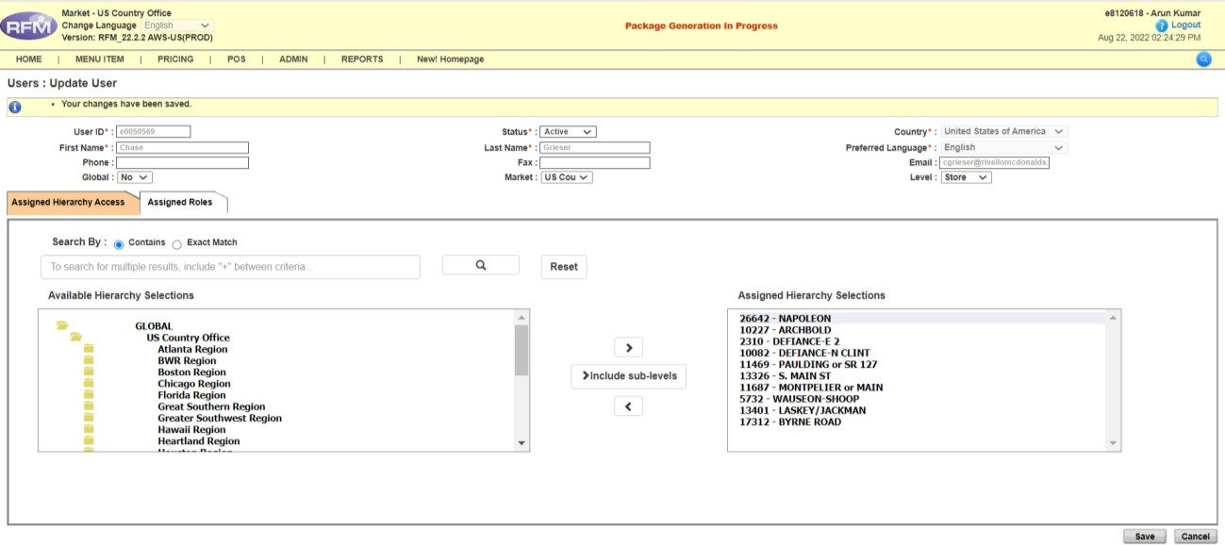
Additional work for MoCopo Store:
1) Company owned to License/franchise change
In case of MoCopo store, if we are converting it from Company owned to license/franchise then we must change the price set name.
Earlier price set name of store: [StoreNumber_MCOPCO_PRICE_LIST]
New price set name: [StoreNumber Price List MMDDYY]
2) License/franchise to Company owned change
In case of normal store, if we are converting it from license/franchise to Company owned then we must change the price set name.
Earlier price set name of store: [StoreNumber Price List MMDDYY]
New price set name: [StoreNumber_MCOPCO_PRICE_LIST]
Validation POST Deployment:
Deployer will send their work to the validator for approval when there is a change in the go-live date. The email to the validator includes the following attachments:
- Survey form
- Audit log
- Access Control by Node report
- Screenshots file
Once the validator confirms the validation, we proceed to send the final email confirmation to the OTM.

Final Email Formats:

Traditional COO:
Hi [OTM Name],
The ownership changes have been completed in RFM2 as outlined in the attached change of ownership request form. Access has been provided to you and those individuals you have identified in the attached form. No other user(s) will have access to the restaurant(s) in RFM2 until you request access for them via Global Account Manager (GAM). Please follow the steps in the GAM document requesting access should you choose to do so.
It’s recommended that you contact McDpricing@deloitte.com or call Carissa Stich, Deloitte Operations Manager, at 813-495-4802 to verify if any future price feed was proposed by the previous owner/operator.
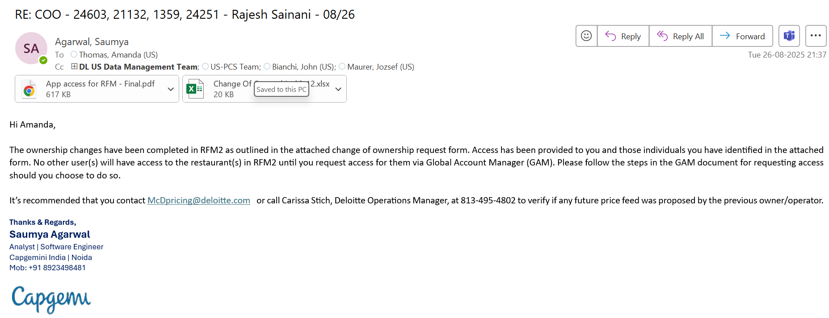

Silent COO:
Hi [OTM Name],
The ownership changes have been completed in RFM2 as outlined in the attached change of ownership request form. Access has been provided to you and those individuals you have identified in the attached form. No user access has been removed as this is a silent change of ownership. Please follow the steps in the GAM document requesting access should you choose to do so.
It’s recommended that you contact McDpricing@deloitte.com or call Carissa Stich, Deloitte Operations Manager, at 813-495-4802 to verify if any future price feed was proposed by the previous owner.
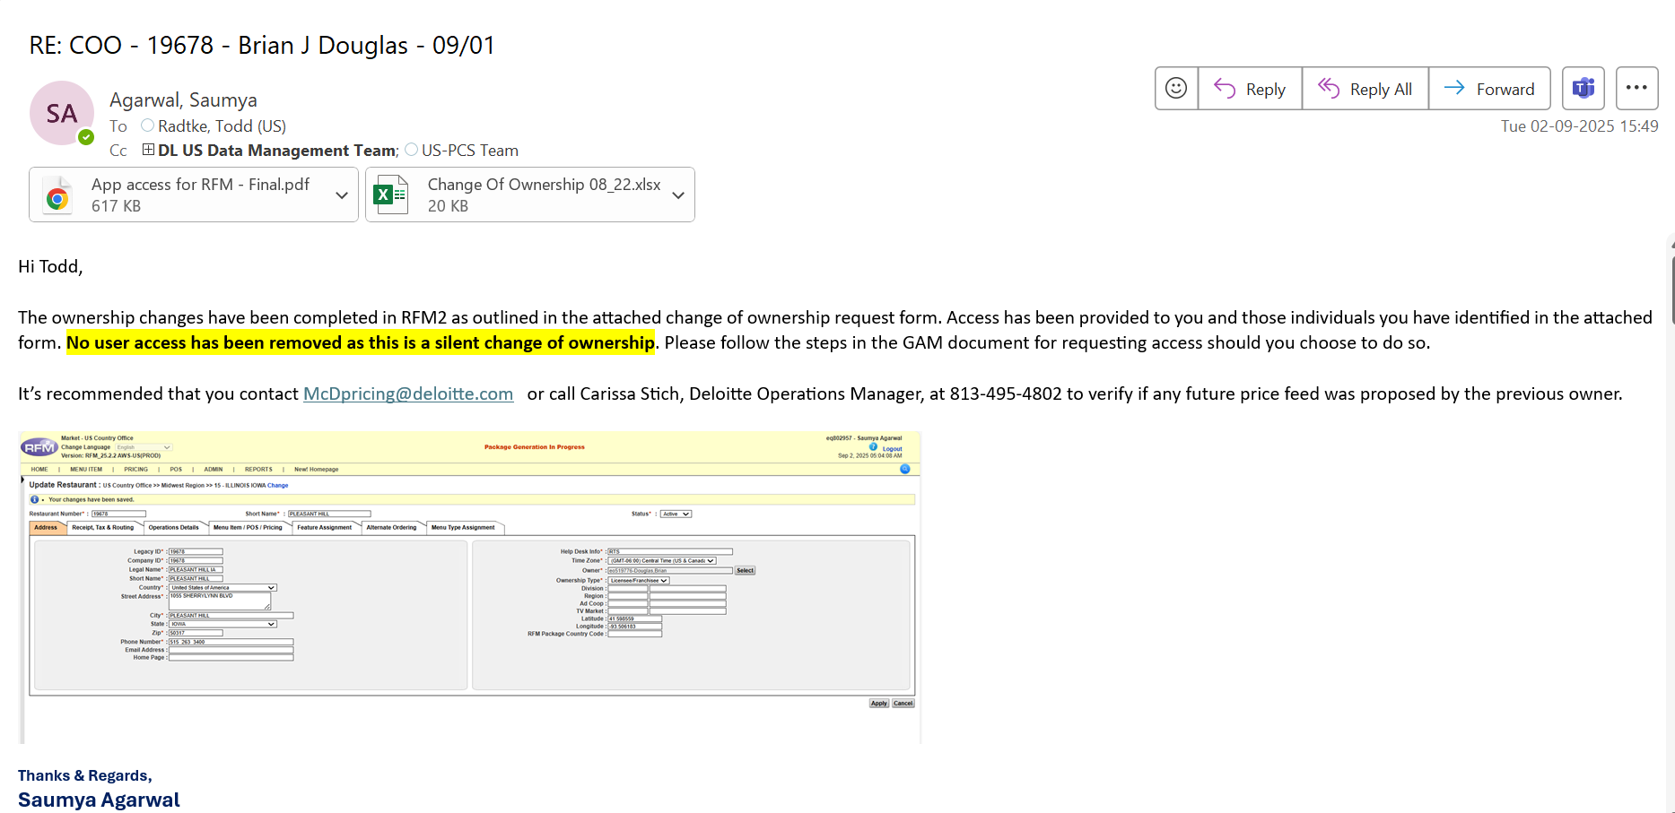

Created By,
Saumya Agarwal
saumya.b.agarwal@capgemini.com
US – Technology RFM

